Đinh Hoàng Sáng

BEBEIU17022

Result:

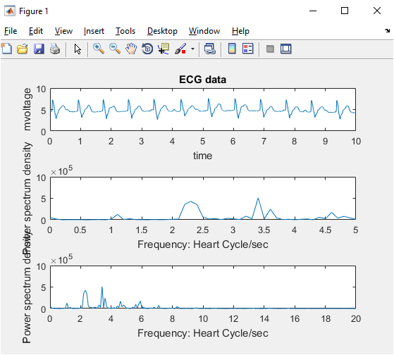

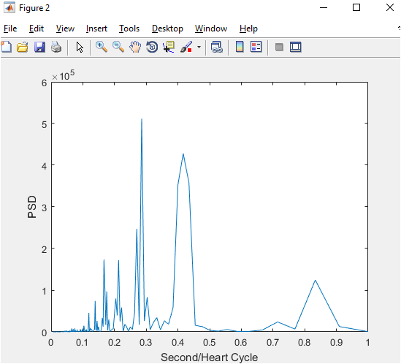



Code:

load('107m (24).mat') %get val from pacemaker rhytm, 1x3600

%gain = 200

val = val/200; %mV

data = val(1,1:3600); %get data at row 1, 3600 column

fs = 360; %360Hz

time_axis = (1:length(data))/fs; %10s 3600/360=10s

figure(1)

subplot(3,1,1); %3 row 1 column

plot(time_axis,data); %show ECG signal

xlabel('time')

ylabel('mvoltage')

title('ECG data')

change=fft(data); %furio transform

length_change=length(change);

change(1)=[];

power1=abs(change(1:floor(length_change/2))).^2;

power2=abs(change(1:floor(length_change/2))).^2;

fred=linspace(0,fs/2,floor(length_change/2));

subplot(3,1,2);

plot(fred,power2);

xlim([0 5]);

xlabel('Frequency: Heart Cycle/sec')

ylabel('Power spectrum density')

subplot(3,1,3);

plot(fred,power1);

xlim([0 20]);

xlabel('Frequency: Heart Cycle/sec')

ylabel('Power spectrum density')

numsPeaks=12;

fprintf('heart rate: %f bpm ', numsPeaks*6);

maxfreq = fs/2;

freq = (1:length_change/2)/(length_change/2)*maxfreq;

figure(2)

period = 1./freq;

subplot(1,1,1);

plot(period,power1);

xlim([0 1]);

xlabel('Second/Heart Cycle')

ylabel('PSD')